PLACEMENT DATA REPORT AFTER ANALYSIS:

* FINAL DECISION WITH THE INIFORMATION:

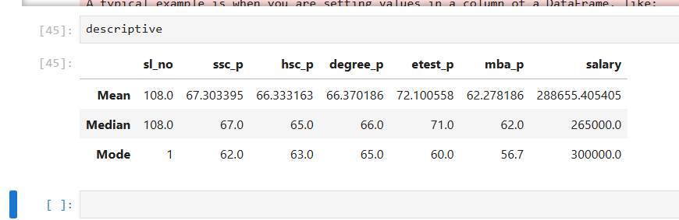

* With the above information , in the placement point of view , they took average of pass (mean)marks in 10th SSLC is 67 which is above average and 12th HSC marks is 66 also .
* Average marks in DEGREE is 66 and ENTERANCE pass marks is 72 , MBA marks is also above average like 62,
* They also take the same level marks when we take the median without consideration of outlier of SSLC,HSC,DEGREE,MBA ,ENTERANCE exams and 67,65,66,71,62 respectively.
* We took mode value for each values because that tells like they took the same level marks in each of students in each stage in SSLC,HSC,DEGREE,ENTERANCE,MBA and 62,63,65,60,56 respectively.